**Instruction to deploy and run code**

**Instruction to run code**

* Download Anaconda from this link: <https://www.anaconda.com/products/individual>
* Download the suitable version according to the system requirements

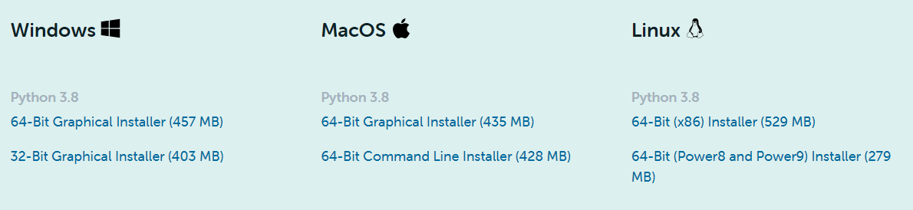

* After installing Anaconda, open the Anaconda prompt.

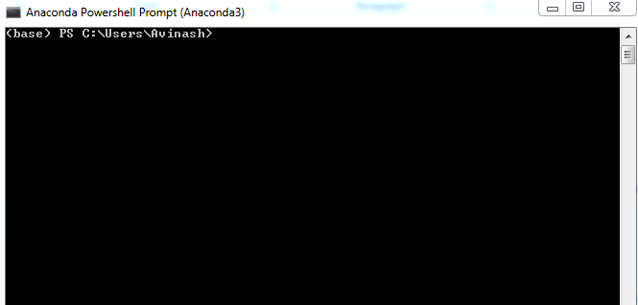

* Navigate to the directory where the notebook is saved. Then type the command ‘jupyter notebook’ and the program will instantiate a local server at localhost:8888 (or another specified port).  
  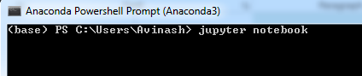
* A browser window should immediately pop up with the Jupyter Notebook interface, otherwise, you can use the address it gives you. The notebooks have a unique token since the software uses pre-built Docker containers to put notebooks on their own unique path. To stop the server and shutdown the kernel from the terminal, hit control-C twice.  
  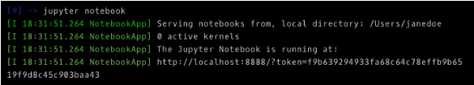
* In the Jupyter Notebook interface, you can see all of the files in your current directory. All Jupyter Notebooks are identifiable by the notebook icon next to their name. Open the Jupyter notebook (Bank_Loan_Default-Python.ipynb) saved in the current directory.

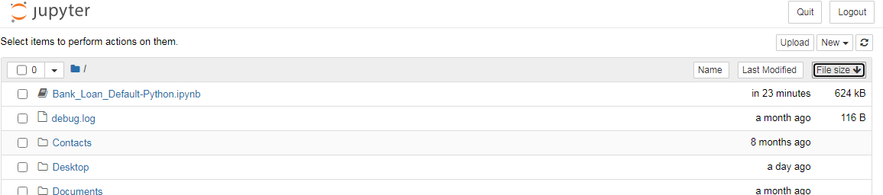

* To run the notebook, click on the ‘Cell’ in toolbar and select ‘Run All’.  
  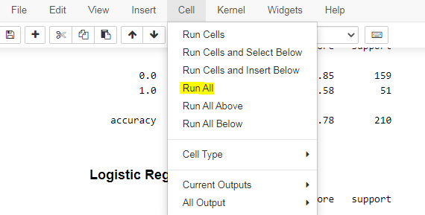

* The code will run now.

**Instruction to deploy the model**

* Here are the instructions to deploy the model in Heroku using streamlit.
* Streamlit is an open-source Python framework that allows to create beautiful interactive websites for Machine Learning and Data Science projects.
* Create app for the bank loan default prediction model.
* import streamlit as st  
  import pandas as pd  
  import numpy as np  
  import pickle  
    
  # loading the trained model  
  pickle_in = open('model.pkl', 'rb')  
  model = pickle.load(pickle_in)  
    
    
  # defining the function which will make the prediction using the data which the user inputs  
  def prediction(age, ed, employ, address, income, debtinc, creddebt, othdebt):  
    
   # Making predictions  
   prediction = model.predict(  
   [[age, ed, employ, address, income, debtinc, creddebt, othdebt]])  
    
   if prediction > 0.473647:  
   pred = 'Default'  
   else:  
   pred = 'No Default'  
    
   return (pred)  
    
    
  # this is the main function in which we define our webpage  
  def run():  
   # front end elements of the web page  
   html_temp = """   
   <div style ="background-color:yellow;padding:13px">   
   <h1 style ="color:black;text-align:center;"> Bank Loan Default Prediction App</h1>   
   </div>   
   """  
    
   # display the front end aspect  
   st.markdown(html_temp, unsafe_allow_html=True)  
    
   # following lines create boxes in which user can enter data required to make prediction  
   age = st.number_input('Age of Customer', min_value=18, max_value=100, value=18)  
   ed = st.number_input('Education Category', min_value=0, value=1)  
   employ = st.number_input('Employment status', min_value=0, value=18)  
   address = st.number_input('Geographic area', min_value=0, value=2)  
   income = st.number_input('Gross Income', value=1)  
   debtinc = st.number_input('Individuals debt', value=1)  
   creddebt = st.number_input('Debt-to-Credit Ratio', value=1)  
   othdebt = st.number_input('Any other debts', value=1)  
   result = ""  
    
   # when 'Predict' is clicked, make the prediction and store it  
   if st.button("Predict"):  
   result = prediction(age, ed, employ, address, income, debtinc, creddebt, othdebt)  
   st.success('Prediction: {}'.format(result))  
    
  run()
* Save the app as app.py
* Now that we have our application we are ready to start deploying the application to Heroku.
* Needed files:
* requirements.txt: The requirements.txt file contains all the libraries that need to be installed for the project to work. This file can be created manually by going through all files and looking what libraries are used or automatically using something like pipreqs.  
  

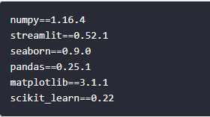

* setup.sh: In the setup.sh file we will create a streamlit folder with a credentials.toml and a config.toml file.  
  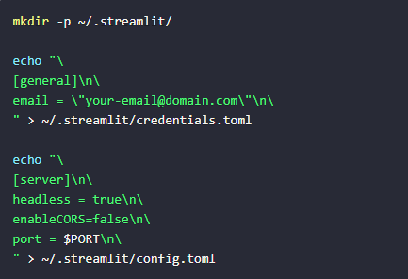
* Procfile: The Procfile is used to first execute the setup.sh and then call streamlit run to run the application.  
  
* Create a Git repository in the same directory where the files are saved. A Git repository can be created with **git init**.

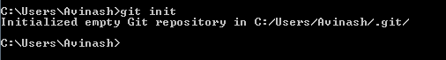

* Create a Heroku Account: https://signup.heroku.com/
* Install the Heroku Command Line Interface (CLI): <https://devcenter.heroku.com/articles/getting-started-with-python#set-up>
* Login to Heroku



* Deploy the Application: Deploy application to heroku by running heroku create to create an Heroku instance.



* Push the code to that instance using the following commands.

**git add .**

**git commit -m "bank default"**

**git push heroku master**

* It should automatically detect that you have a Python app and it should install all packages inside the requirements.txt.
* Check if the application was deployed successfully using **heroku ps:scale web=1.**
* The application can be opened with **heroku open**. This will open the app using the default browser.

App deployed: <https://bank-loan-default-python.herokuapp.com/>

Github repository: <https://github.com/avinashsajeevan/Bank-Loan-Default-Prediction--Python>

